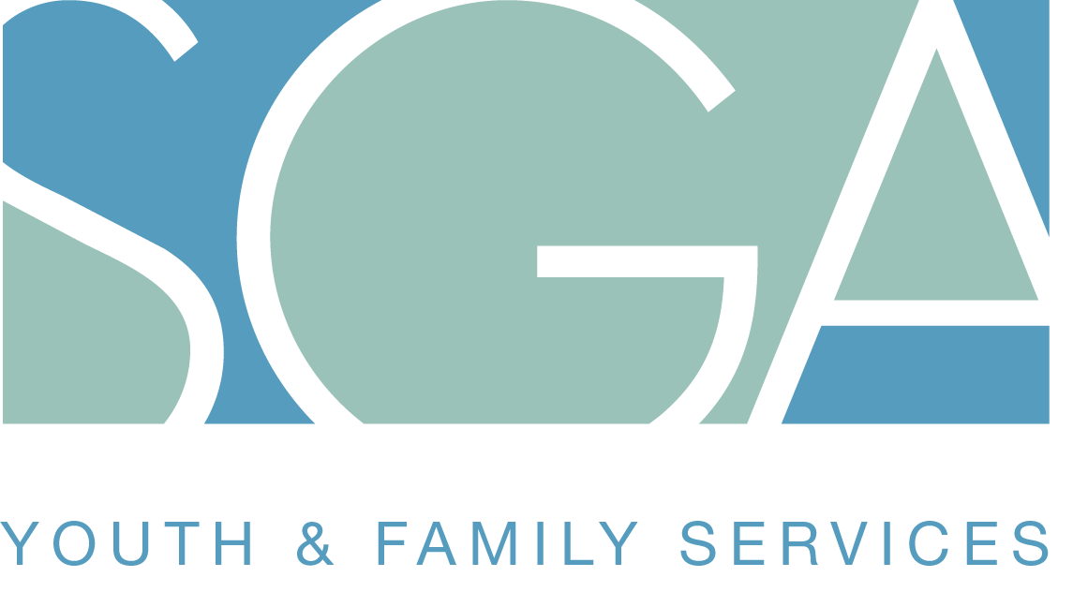
SGA Youth & Family Services Job Description
Position Title | Thrive Youth Council Member
Location | Chicago Land Area | Date Compiled | February 2015

The Thrive Youth Council is seeking youth, ages 18-24, who are looking to make a meaningful difference in the city of Chicago. Thrive Youth Council members will work together to identify a problem confronting youth in Chicago and develop and implement a solution. Council Members will receive a monthly stipend of $100, based on attendance and Ventra cards to and from council meetings. Councils will convene for 4 months (there will be two cohorts; youth will have an option to continue into 2nd cohort). Summer will include opportunities for youth employment and worksite placement.

Key Areas of Responsibility:

- Participate to develop and implement action to make meaningful change in the Chicago community.
- Attend and participate bi-weekly meetings at predetermined locations
- Agree to roles and responsibilities within the group dynamic to brainstorm, plan, and develop a strategy or presentation to Thrive Council members
- Demonstrate key 21st century skills including personal mindset, planning for success, social awareness, verbal communication, collaboration, and problem solving; provide and receive constructive criticism
- Communicate with Thrive Leader on a weekly basis to develop goals and personal benchmarks that include, but are not limited to: employment placement, educational pathways, and supportive services.
- Travel to various communities in the City to attend meetings and events
- Work in collaboration with other youth, Thrive Council Members, community and faith-based organizations, and political representatives
- Some evening and weekend availability required.

SGA will provide the following support services:

- Support services for travel (Ventra Cards)
- Monthly stipends to participate in council meetings
- Mentor for additional support needed

Outcomes for Council Members:

- Workforce development skills that include resume building, interview skills, job applications
- Coaching, mentoring, leaderships skills to set members apart for job interviews and post-secondary applications
- Meet and network with leaders in Chicago government, business, and philanthropy.

Eligibility:

- 18-24 years old youth who are not enrolled in school or employed, or has re-enrolled into school
- Chicago residents

Next Steps and Application Process:

Youth who are interested should submit a brief narrative as to why they would like to join the council (1-2 paragraphs) to: jroth@sga-youth.org. Once youth have completed this form and the narrative, youth will be invited to participate in an interview before final selection for council participation.

Please complete and return the following to jroth@sga-youth.org (can be submitted before narrative is submitted):

Youth Name: Age: Date:

Youth Phone Number: Youth E-mail:

Agency Name Referral: Agency Representative:

Agency Rep. Phone Number: Agency Rep. E-mail:

